**Lab 1: Using AWS Systems Manager**

Spurthy Mutturaj

Information Technology, Arizona State University

IFT562: Cloud Security & Operations for IT

Daniel Wells

Sep 3,2023

**Lab 1: Using AWS Systems Manager**

**Figure 1**

*A screenshot of task 1's inventory list*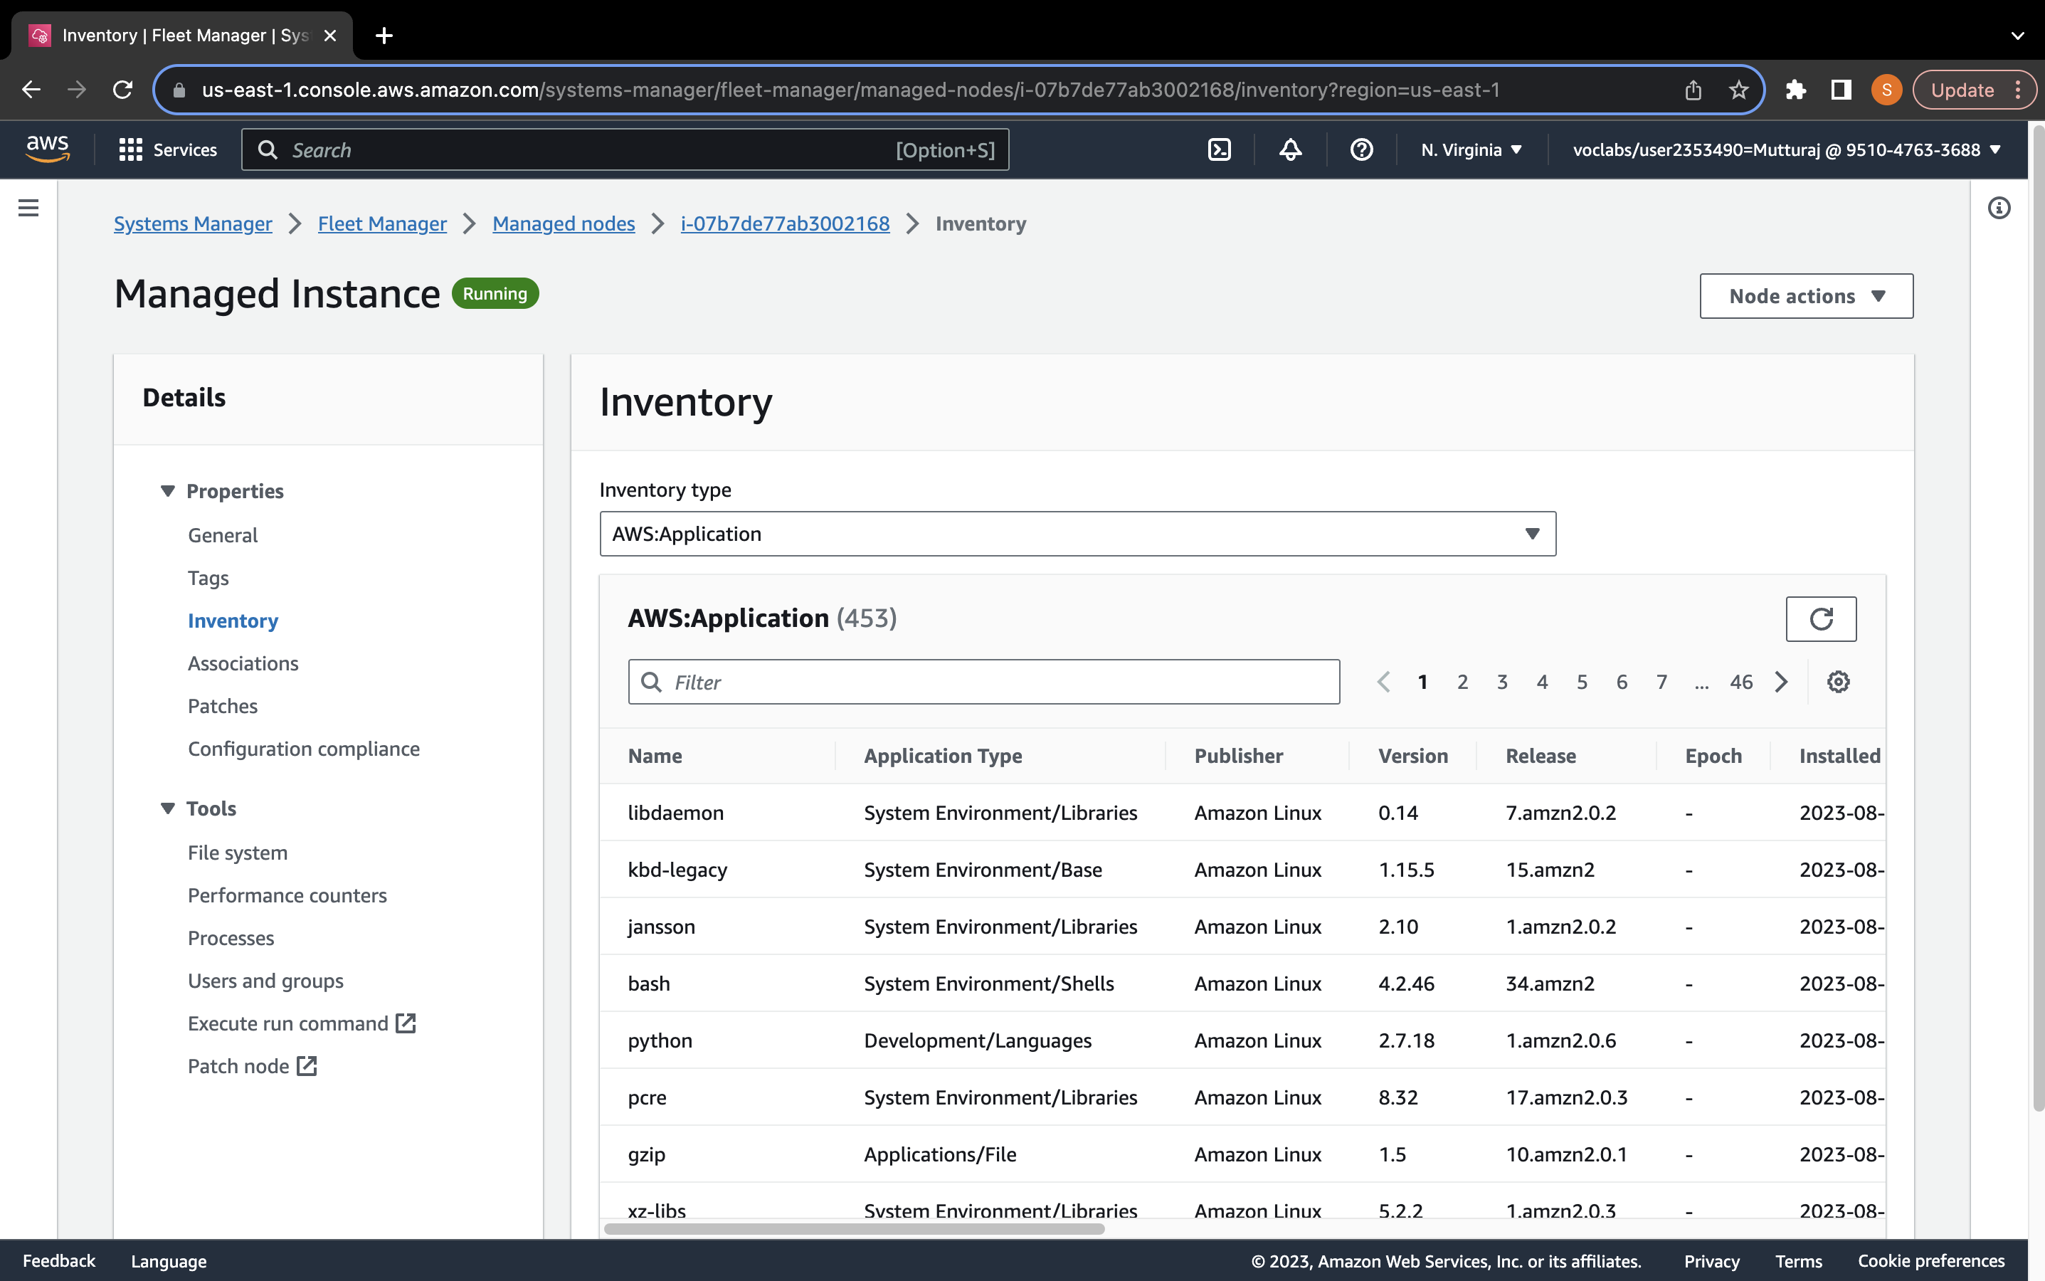

**Figure 2**

*The web page of Widget Manufacturing Dashboard*

**Figure 3**

*Screenshot of list of parameters.*

**Figure 4**

*Screenshot of the CLI from Task 4*

*Note.* Name added after ls command.